PowerShell Teams Message Script Documentation
This guide explains how to deploy a PowerShell script that delivers Adaptive Card messages to users in Microsoft Teams. The script leverages the Microsoft Graph API for its messaging and uses parallel processing to increase efficiency and minimize file read/write operations.
The Adaptive Card features six buttons, each linked to a distinct prompt. Clicking a button opens a new browser tab, with the selected prompt copied into a dialog box for review or editing before sending. This setup enables users to easily tailor and submit prompts.
High-Level Design
The script operates based on the following high-level design principles:
- Authentication: Establishes a connection to the Microsoft Graph API using modern authentication with specified scopes (Chat.ReadWrite, User.Read).
- Input Data: Reads a list of User Principal Names (UPNs) from a specified Excel file using the ImportExcel module.
- Adaptive Card: Loads the content of an Adaptive Card from a JSON file. This card will be sent as the message payload in Teams chats.
- Parallel Processing: Utilizes the ForEach-Object -Parallel cmdlet (available in PowerShell 7+) to process the list of UPNs concurrently. This significantly speeds up the message sending process compared to sequential execution.
- Concurrent Chat Creation and Message Sending: Within each parallel thread, the script performs the following steps for a given UPN:
  - Creates a one-on-one chat conversation with the target user and the script's executing user.
  - Constructs the message body, embedding the Adaptive Card as an attachment.
  - Sends the message containing the Adaptive Card to the newly created chat.
- Retry Mechanism: Implements a retry loop with exponential backoff and jitter to handle transient errors during chat creation or message sending. It attempts to respect the Retry-After header from Graph API responses if present.
- Concurrent Logging: Employs a [System.Collections.Concurrent.ConcurrentBag] to collect log messages (success, error, retry attempts) from all parallel threads in a thread-safe manner. This avoids multiple threads writing to the log file simultaneously, which can cause performance issues and data corruption.
- Single Log File Output: After all parallel processing is complete, the script writes all the collected log messages from the ConcurrentBag to a single timestamped CSV log file. This minimizes file I/O operations during the execution.
- Cleanup: Disconnects the Microsoft Graph session upon completion.
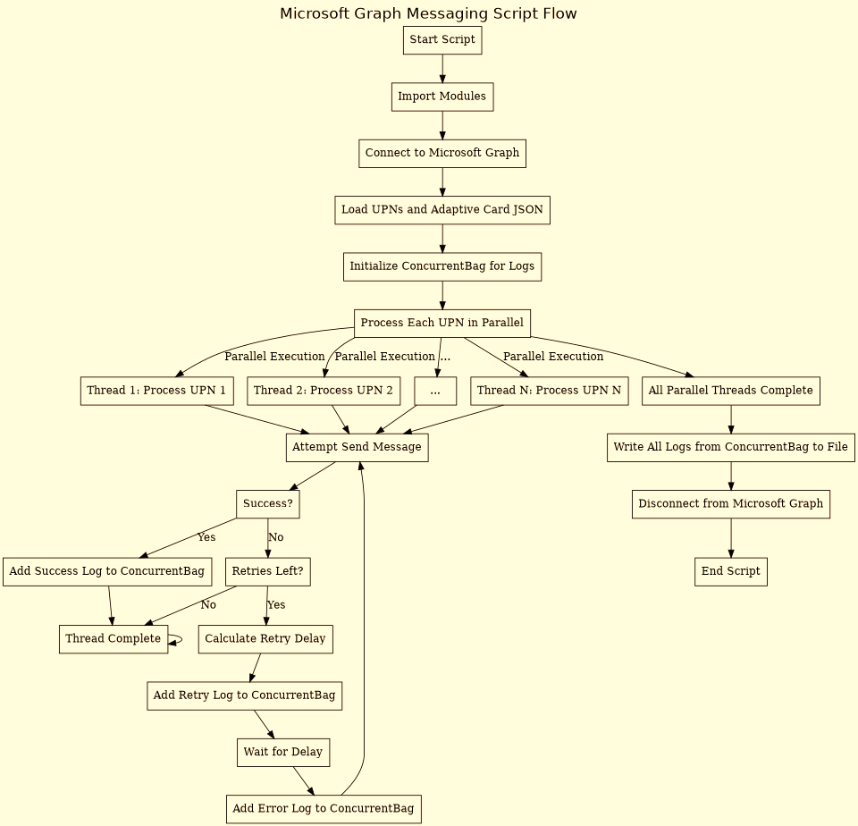
Prerequisites
Before deploying and running this script, ensure you have the following:
- PowerShell 7.0 or later: ForEach-Object -Parallel is required.
- Required PowerShell Modules:
  - ImportExcel: Used to read UPNs from an Excel file. Install using Install-Module -Name ImportExcel.
  - Microsoft.Graph.Teams: Contains cmdlets for interacting with Teams chats and messages. Install using Install-Module -Name Microsoft.Graph.Teams.
  - Microsoft.Graph.Authentication: Required for connecting to Microsoft Graph. Install using Install-Module -Name Microsoft.Graph.Authentication.
- Microsoft Graph Permissions: The user account running the script must have sufficient permissions to create chats and send messages. The script requests Chat.ReadWrite and User.Read scopes, which are necessary. You may need to grant admin consent for these permissions in your Azure Active Directory/Microsoft Entra ID tenant.
- Input Excel File: A .xlsx or .xls file containing a column named UPN with the User Principal Names of the target users.
- Adaptive Card JSON File: A valid JSON file containing the structure of the Adaptive Card you wish to send.
- Account/ID for sending message:One account to run the script which should have Teams license as the messages would besent using this account
Deployment and Configuration
- Save the Script: Save the provided PowerShell code as a .ps1 file (e.g., SendTeamsAdaptiveCard.ps1).
- Place Input Files:
  - Place your Excel file containing UPNs in a known location.
  - Place your Adaptive Card JSON file in a known location.
- Configure Script Variables: Open the .ps1 file in a text editor and modify the following variables in the "Configuration" section:
  - $excelFilePath: Set this to the full path of your input Excel file (e.g., "C:\Scripts\Users.xlsx").
  - $adaptiveCardPath: Set this to the full path of your Adaptive Card JSON file (e.g., "C:\Scripts\MyAdaptiveCard.json").
  - $logFile: The script automatically generates a timestamped log file name in the specified directory. Ensure the directory path ("C:\Users\avichandra\Downloads\CopilotChat-Nudges\" in the example) exists or can be created by the script. You can change this base directory.
  - $ThrottleLimit: Adjust this value based on your system's resources and the desired level of concurrency. A higher number means more threads run simultaneously. Start with a lower number (like 5 or 10) and increase if your system can handle it.
  - $retryLimit: Set the maximum number of times the script should retry sending a message to a user if an error occurs.
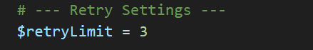

How to Run
- Open PowerShell 7 or later.
- Navigate to the directory where you saved the script using cd <path_to_script_directory>.
- Run the script: .\SendTeamsAdaptiveCard.ps1
- You will be prompted to authenticate with Microsoft Graph. Follow the on-screen instructions to sign in with an account that has the necessary permissions.
One Time consent is prompted for Graph permission:
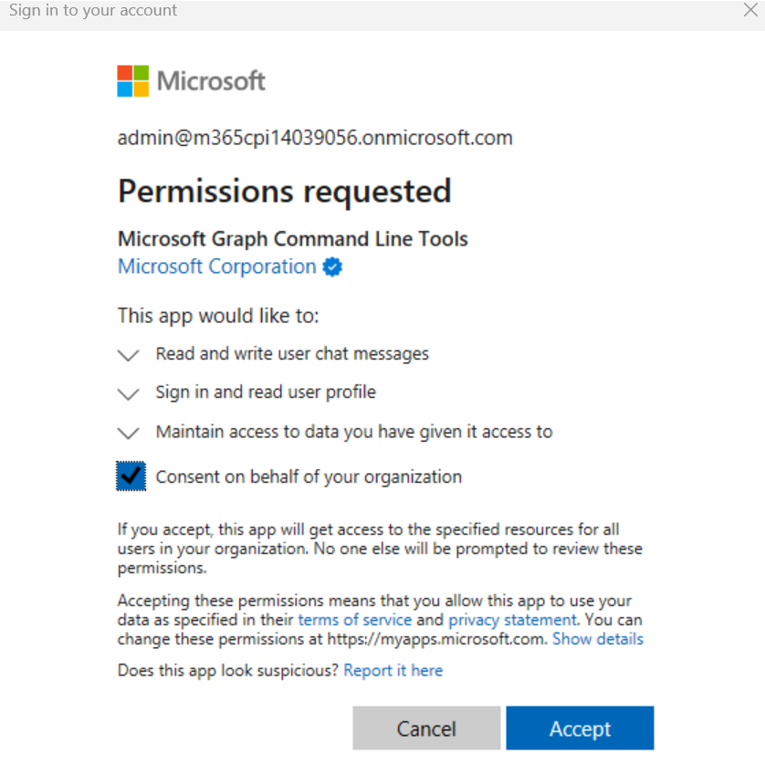
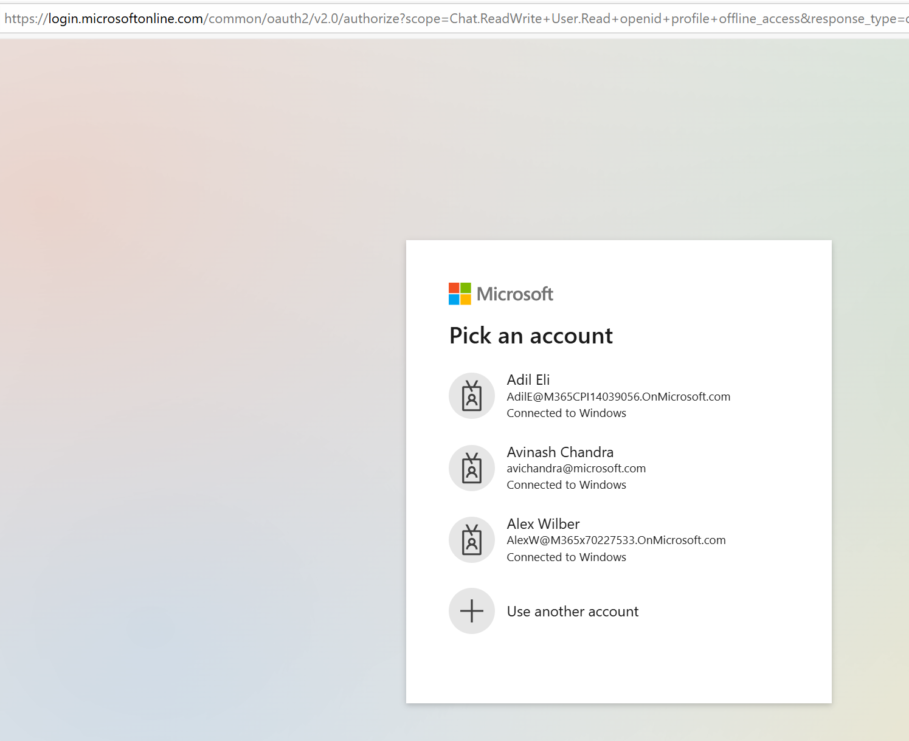
- The script will start processing the UPNs in parallel, displaying progress and status messages in the console.
- 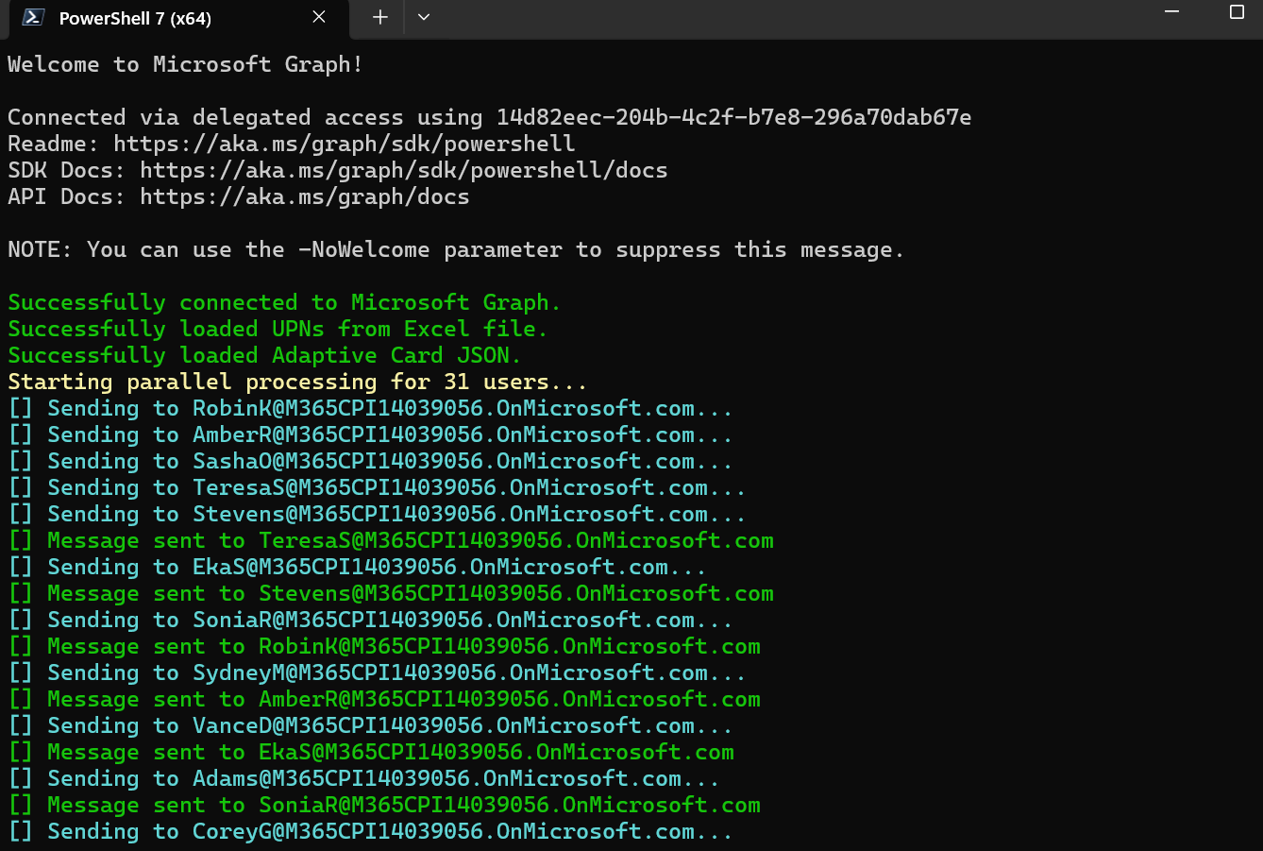
- Upon completion, the script will disconnect from Microsoft Graph and indicate the total time taken.
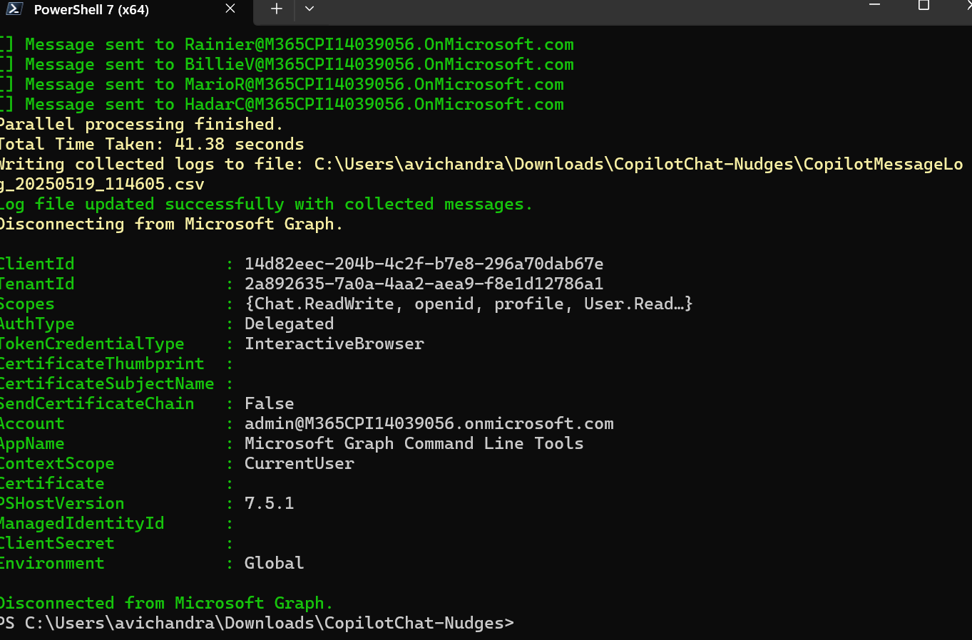
- A log file named CopilotMessageLog_YYYYMMDD_HHMMSS.csv (where MMDD_HHMMSS is the timestamp) will be created in the specified log directory, containing the results of each message sending attempt.
Logging
The script uses a ConcurrentBag to collect log entries during parallel execution. This ensures that logging from multiple threads is handled safely.
- Each log entry includes a timestamp, the UPN of the target user, the status (Success, Error, or Retry), and a relevant message.
- These entries are stored in memory until all parallel tasks are finished.
- Finally, all collected logs are written to the timestamped CSV file in a single operation.
Error Handling and Retries
The script includes a try/catch block within the parallel loop to handle potential errors during chat creation or message sending.
- If an error occurs, the script will log the error and attempt to retry sending the message up to the number specified by $retryLimit.
- It implements an exponential backoff strategy with jitter for retries, waiting for a longer duration after each failed attempt.
- If the error response from the Graph API includes a Retry-After header, the script will wait for the duration specified by that header before retrying.
- After reaching the $retryLimit, the script logs a final error message for that user.

End user experience
End user will receive the one of the following adpative card message. If script uses (adaptiveCardActions.JSON)
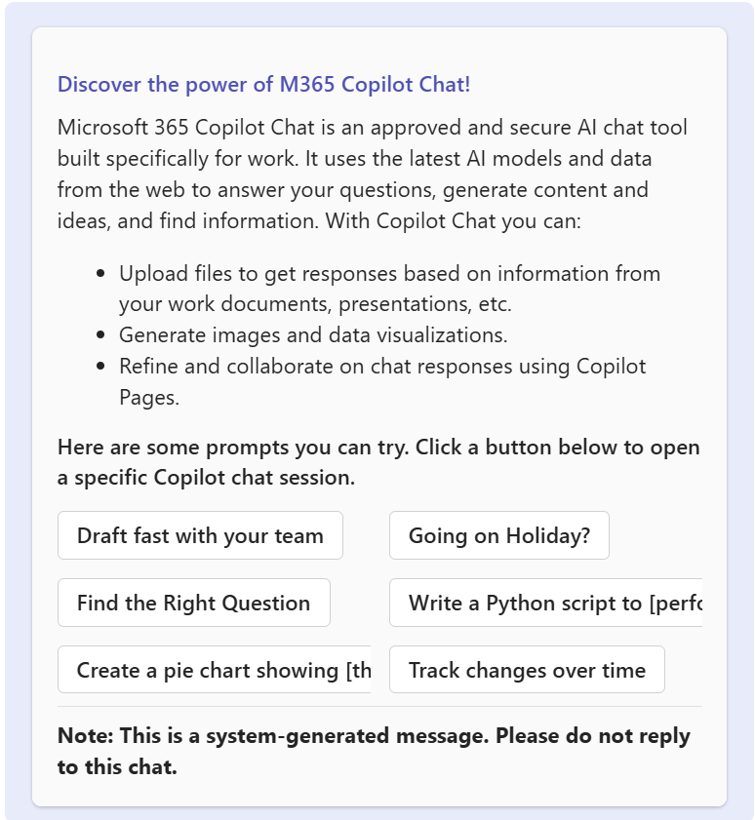
When the user click any of the button:
When the user clicks any button from the adaptive card, say he/she clicked a button labelled "Going on Holiday," the respective adaptive card action triggers, opening a new tab for Copilot chat with the prompt copied in the Prompt Dialog box. The user can click send or modify the prompt as needed. See the screenshot below for reference.
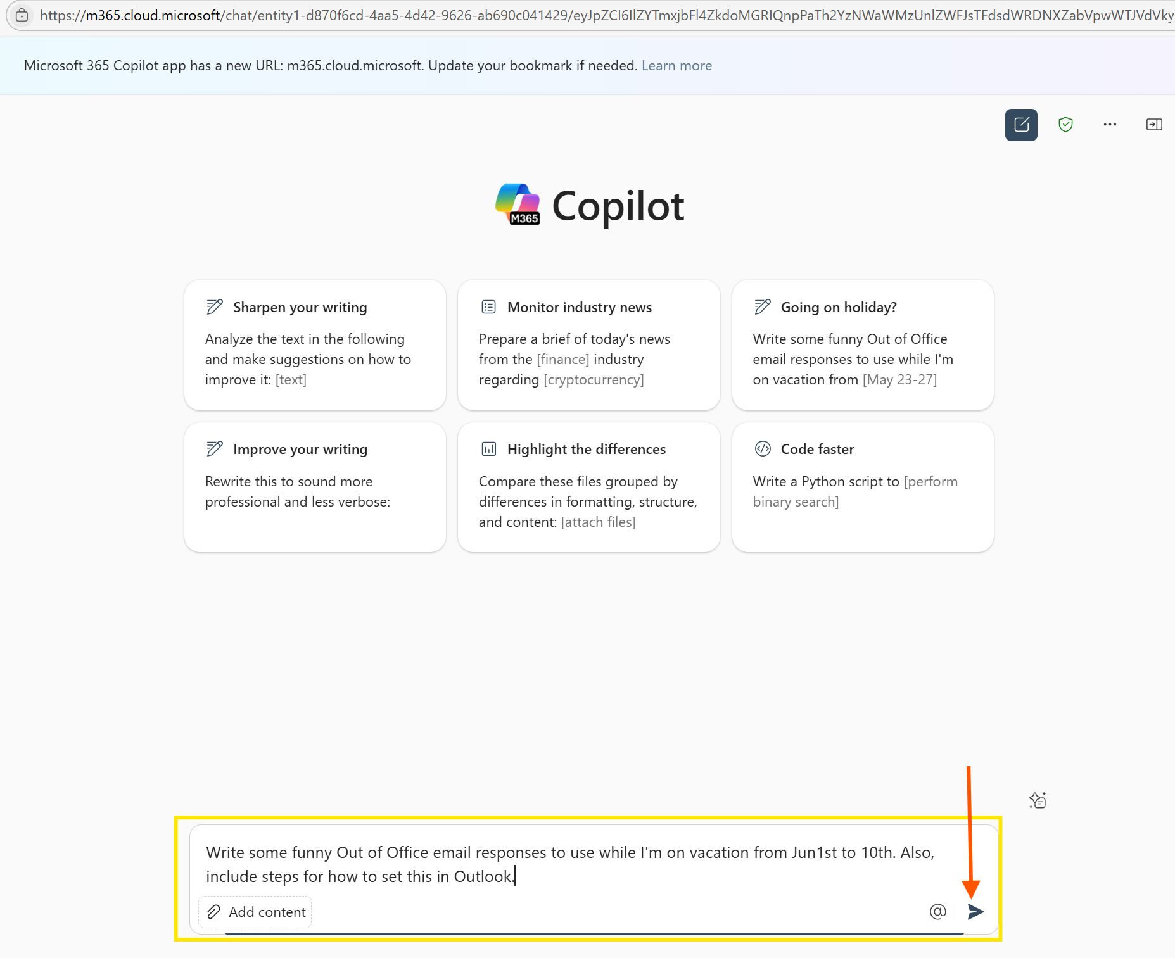

If script uses the other adative card (adaptiveCardMsg.JSON) user will receive below message.
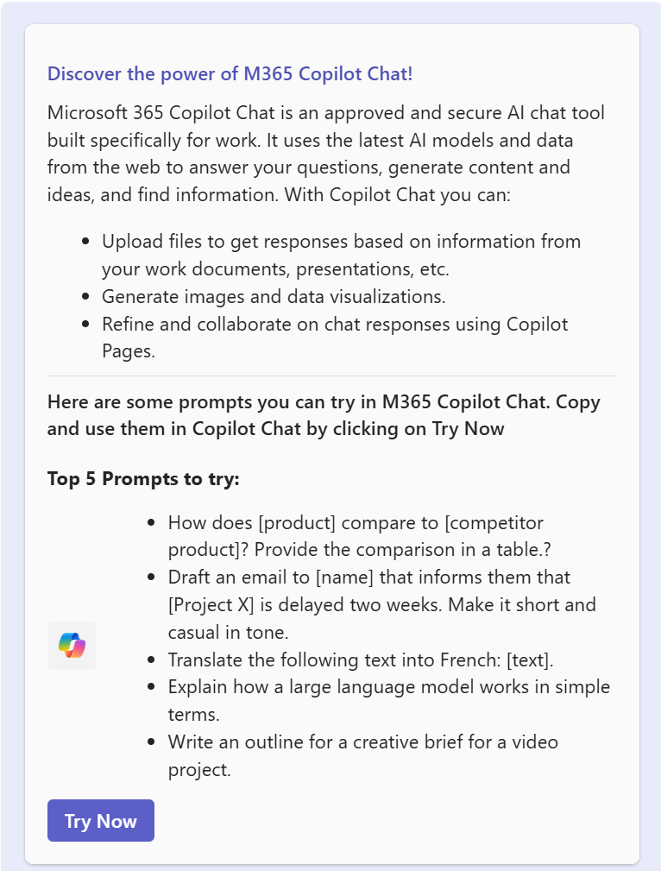

Troubleshooting
Here are some common issues you might encounter and how to resolve them:
- ForEach-Object -Parallel is not recognized:
  - Issue: This cmdlet parameter is only available in PowerShell 7.0 and later.
  - Solution: Ensure you are running the script in a PowerShell 7 or newer environment. You can check your version by typing $PSVersionTable.PSVersion in a PowerShell console.
  - If you have an older version (like Windows PowerShell 5.1), you will need to install PowerShell 7 from the official Microsoft documentation.
Installing PowerShell on Windows - PowerShell | Microsoft Learn
winget install --id Microsoft.PowerShell --source winget
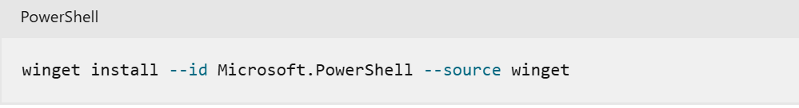
- Script cannot be loaded because the execution of scripts is disabled on this system:
  - Issue: Your PowerShell execution policy is set to restrict running unsigned scripts.
  - Solution: You can temporarily or permanently change the execution policy to allow running local scripts.
    - Check current policy: Get-ExecutionPolicy -list
    - Allow local scripts (recommended for running your own scripts): Set-ExecutionPolicy -ExecutionPolicy RemoteSigned -Scope CurrentUser
    - Allow all scripts (use with caution): Set-ExecutionPolicy -ExecutionPolicy Unrestricted -Scope CurrentUser
or
    - Set-ExecutionPolicy -Scope Process -ExecutionPolicy Bypass
- Permission errors when connecting to Microsoft Graph or sending messages:
  - Issue: The user account used for authentication does not have the necessary Microsoft Graph permissions (Chat.ReadWrite, User.Read).
  - Solution: Verify that the account used to Connect-MgGraph has been granted the required API permissions in Azure Active Directory/Microsoft Entra ID. If using an app registration, ensure the correct permissions are assigned and consented to. You may need administrative privileges to grant consent.
- Module not found errors (e.g., ImportExcel, Microsoft.Graph.Teams):
  - Issue: The required PowerShell modules are not installed on the system where you are running the script.
  - Solution: Install the missing modules using Install-Module -Name <ModuleName>. For example:
  - Install-Module -Name ImportExcel
  - Install-Module -Name Microsoft.Graph.Teams
  - Install-Module -Name Microsoft.Graph.Authentication

You might need to run PowerShell as an administrator to install modules globally, or you can install them for the current user using the -Scope CurrentUser parameter.
Cleanup
The script automatically disconnects from the Microsoft Graph session at the end of execution using Disconnect-MgGraph

Disclaimer
This is a sample script provided for demonstration purposes only. It is your responsibility to test and validate the script thoroughly before using it in production. Modify it to meet your organizational and compliance requirements.

